A1374-EUR-FR-Paris Basin-Mid. Paleo-Mousterian debitage-Levallois method-100-30 ky BP

Case no.:1

Accession Number: A1374

Formal Label: EUR-FR-Paris Basin Mid. Paleo-Mousterian debitage-Levallois method-100-30 kyBP

**Display Description:**

Flint, blond white patina of the Paris Basin, Middle Paleolithic period of the c, 100.000 to 30.000 BP

**LC Classification: DA90**

Date or Time Horizon: 100.000 to 30.000 BP

Geographical Area: Paris Basin

**Map:**

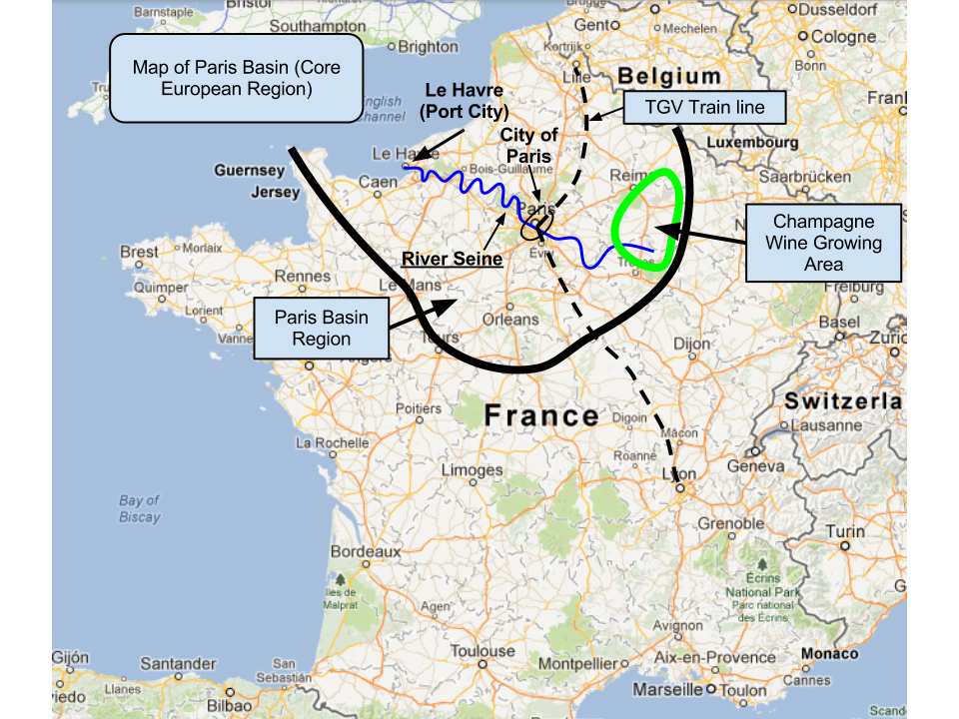

**https://bantrygeography.files.wordpress.com/2013/04/paris-basin-map.png GPS coordinates:**

Cultural Affiliation:

Medium: Paris Basin flint

Dimensions:

Weight:

Condition: original

Provenance: Paris Bain, 1976

**Discussion:** Mousterian debitage-Levallois method

**References:**

Fisher, Lynn E. and Berit Valentin Eriksen. 2002. *Lithic raw material economies in late glacial and early postglacial Europe.* BAR International series; 1093. Oxford: Archaeopress.